Assignment – 2
Constraint Satisfaction Problem.

Problem Statement:
A Constraint Satisfaction Problem (CSP) involves finding values for variables that satisfy a set of constraints or conditions. Each variable must take a value from a predefined domain, and the solution must ensure that all constraints between the variables are met. Common applications include scheduling, map colouring, and Sudoku solving. In this assignment, we aim to implement a CSP and use algorithms like Backtracking to find solutions.

Software used:
- Python 3.x
- Google Colab

Libraries and packages used:
- itertools: To handle combinations or permutations of variables (optional).
- collections: For efficiently storing and retrieving constraint information.
- copy: For creating deep copies of variable assignments during recursive backtracking.

Theory:
A CSP consists of three components:
- Variables: Entities that need to be assigned values.
- Domains: Possible values that each variable can take.
- Constraints: Rules that restrict how variables can be assigned values.
For example, in a map coloring problem, the variables are regions, the domain is the set of colors, and the constraint is that no two adjacent regions can have the same color.
CSP Algorithms:
- Backtracking: A basic algorithm for solving CSPs by exploring the variable assignments one by one and backtracking when a constraint is violated.
- Forward Checking: A technique to reduce the domain of future variables as soon as a value is assigned to a variable.
- Constraint Propagation: Further refines domains by ensuring all future variable assignments remain consistent.

Methodology:
- Define Variables: Identify the variables in the problem (e.g., regions, cells).
- Specify Domains: Assign a set of possible values for each variable.
- Set Constraints: Define constraints between variables (e.g., neighbouring regions must have different colours).
- Implement Backtracking:
- Recursively assign values to variables.
- If all constraints are satisfied, a solution is found.
- If not, backtrack and try a different value.
- Optimization (optional): Use techniques like forward checking or least constraining value to improve efficiency.

Advantages:
- Solves Various Problems: Can be used for map colouring, scheduling, and puzzles like Sudoku.
- Backtracking with Heuristics: Efficient when enhanced with heuristics like Most Constrained Variable (MCV).
- Scalable: CSPs can be extended to handle larger problems using advanced algorithms

Limitations:
- High Computational Cost: Large problems can be computationally expensive to solve without optimizations.
- Memory Usage: Backtracking may require substantial memory for large problem spaces.
- Exponential Time Complexity: In the worst case, solving CSPs can take exponential time without heuristics.

Applications with example:
- Sudoku: Each cell is a variable, with domains from 1 to 9. Constraints ensure no two cells in the same row, column, or 3x3 sub-grid have the same value.
- Scheduling: Variables represent tasks, and constraints enforce task ordering, resource allocation, and time slots.
Example: Consider a CSP where the goal is to schedule three employees (variables) to shifts (domain: Morning, Afternoon, Night) such that no two employees are assigned the same shift. The constraint is to ensure different shifts for each.

Working / Algorithm:
- Initialize the variables, domains, and constraints.
- Define the variables X = {X₁, X₂,...,X_{n}}.
- For each variable, assign its domain D_{i}​.
Step 2: Start the backtracking search.
- Assign a value from the domain to the first variable.
Step 3: Check for constraint satisfaction.
- For the current variable, check if the assignment satisfies all constraints with the previous assignments.
- If the assignment is valid, move to the next variable.
Step 4: Recursion or backtrack.
- If a valid assignment is found, repeat steps 2-3 for the next variable.
- If no valid assignment can be made, backtrack to the previous variable and try a different value from the domain.
Step 5: Termination.
- If all variables have been assigned valid values, the CSP is solved.
- If the algorithm backtracks past the first variable, the problem has no solution.

Diagram:
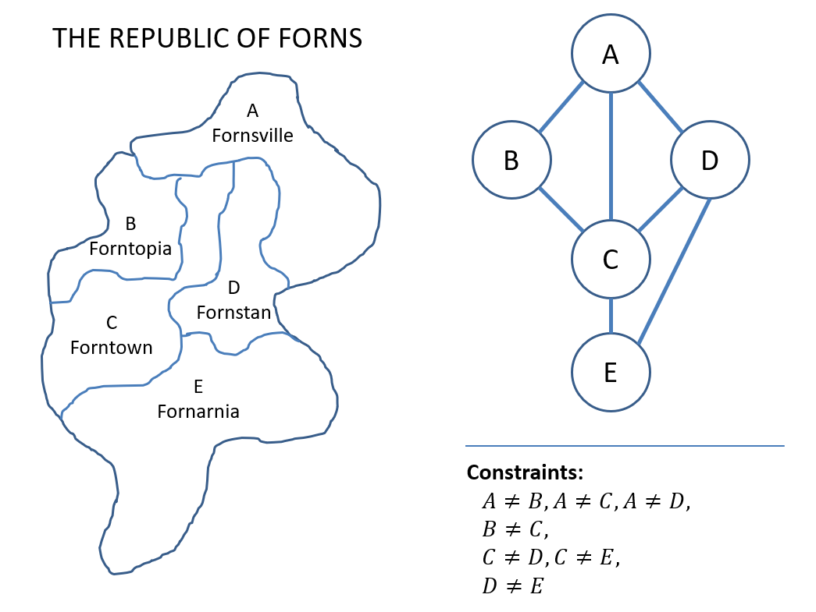
Conclusion:
The implementation of a Constraint Satisfaction Problem (CSP) using the Backtracking algorithm allows for solving a wide range of real-world problems, from scheduling to puzzles. While backtracking provides a simple and effective solution for small-scale problems, advanced techniques like constraint propagation and forward checking can significantly improve efficiency for larger or more complex CSPs. This assignment demonstrates how powerful CSPs are in AI applications, providing the groundwork for solving more sophisticated problems using optimization algorithms.

